Mendelian Genetics Worksheet by C Kohn, WUHS
Names:
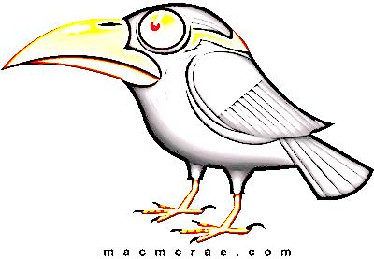
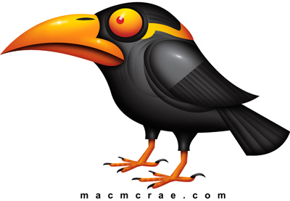
Directions: In your groups of 2, complete the worksheet below. Each question should be answered by a different partner (i.e. you should not answer multiple questions in a row). Initial by the questions you complete.
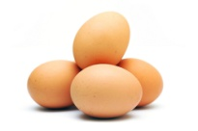
- A male and female bird have 4 unhatched eggs. The female
is on the left heterozygous; the male on the right is homozygous
recessive. Use B or b for your genotypes.
  - Write the genotype of the female (left) below:
  - Write the genotype of the male (right) below:
  - Which color is dominant, gray or black? How do you know?
  - Write the phenotype of the female and the phenotype of the male below:
  - Complete the Punnett Square below for this couple:
  - If they follow the Punnett Square ratios, what will the babies in the eggs look like when they hatch?
  - Will all four offspring adhere exactly to the ratios predicted by the Punnett Square? Explain:
Hint: if I flip a coin and get heads 5 times in a row, what is the likelihood that I will get heads on the next flip?
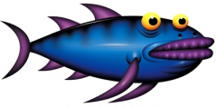
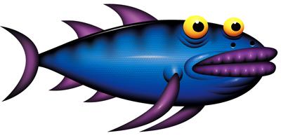
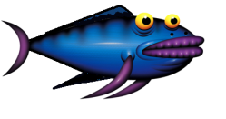
- A family of fish resides in a tank. The instructor, while bored
decides to determine the genotypes of the
parents based on their back fins.
  - What is the dominant phenotype?
  - What is the recessive phenotype?
  - What are the two possible genotypes of the
each adult fish?
  - How many baby fish have the dominant phenotype? How many have the recessive phenotype?
  - Complete both Punnett Squares below, one each for all possible genotypes of the upper adult fish.
  - Circle the Punnett Square above that is correct for the fish shown here.
  - What are the genotypes of the parents?
  - Why are the other Punnett Squares not possible for this family? (assume that the offspring exactly follow the predicted ratios)

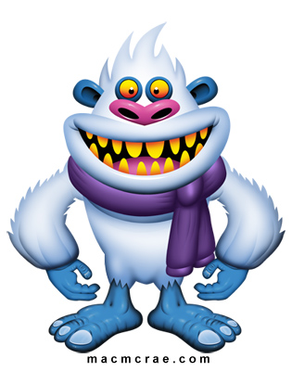
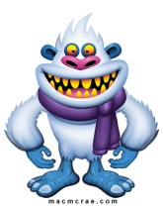
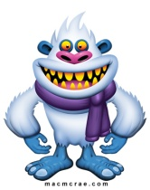
- Two yetis have babies.
  - What is the dominant phenotype?
  - What is the recessive phenotype?
  - What is the genotype of the yeti parent on the left?
  - What are the two possible genotypes of the yeti parent on the right?
  - What are the phenotypes of the yeti babies?
  - Complete both Punnett Squares below, one each for both possible genotypes of the right adult yeti.
  - Circle the Punnett Square above that is correct for the yetis shown here.
  - What are the genotypes of the parents?
  - Why can’t the parents have a different genotype? (assume that the offspring exactly follow the predicted ratios)

- Back fins are dominant on this species of salamander. Could this couple have had this baby? Explain.

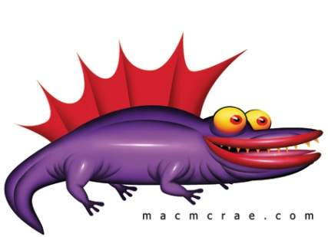

- In the space below, draw a mother and father with four offspring (any kind of animal – you choose). Create two traits for them (color, horns, wings, fins, etc.). Create a dominant and recessive phenotype for each trait. Then describe the genotype of each individual and describe their inheritance patterns (e.g. “the mother was homozygous dominant and the father was homozygous recessive, so all babies are heterozygous for this trait”). Finally complete a Punnett Square for each trait and label what trait each square represents.

