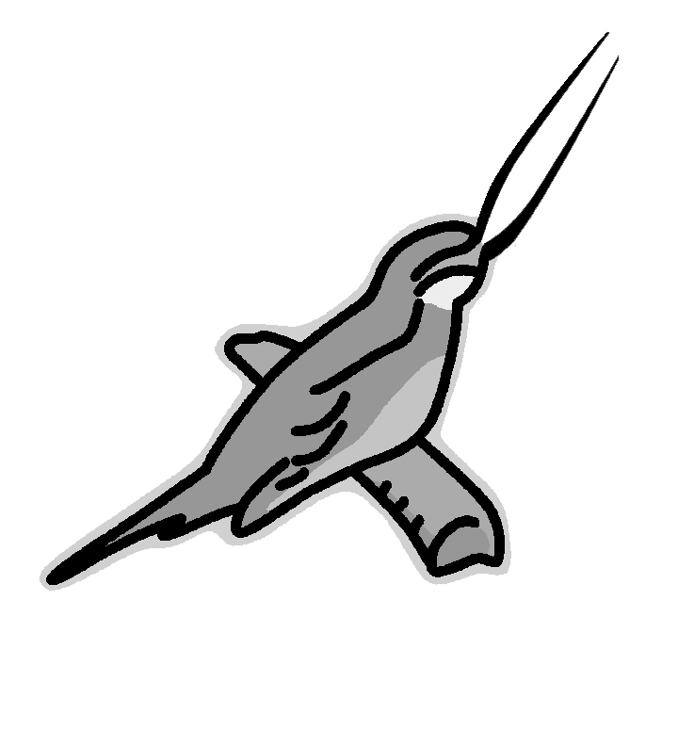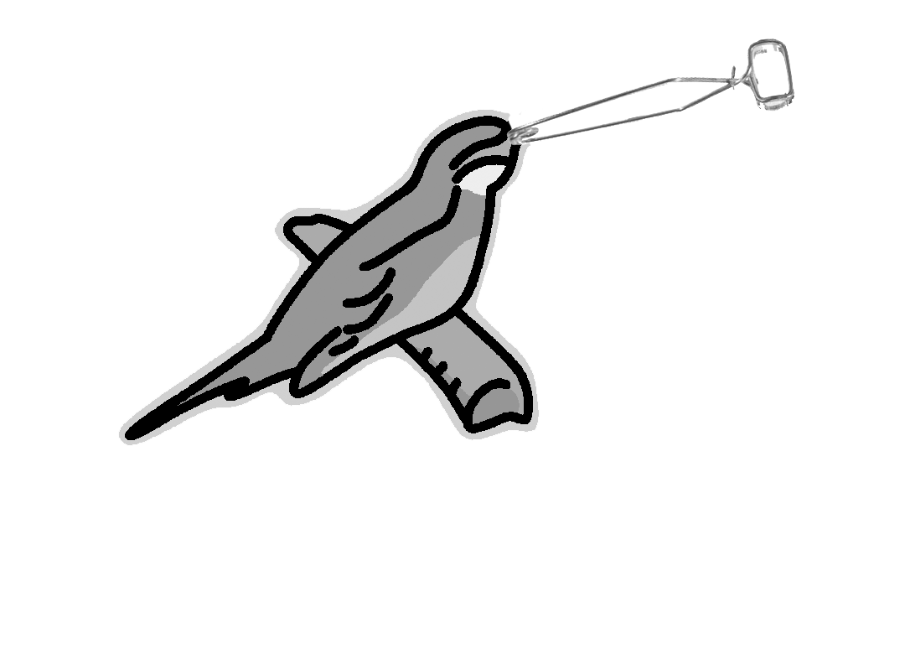
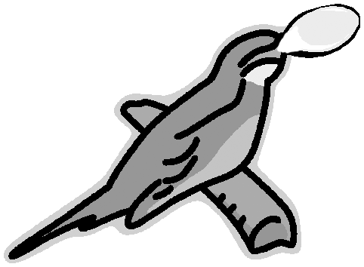
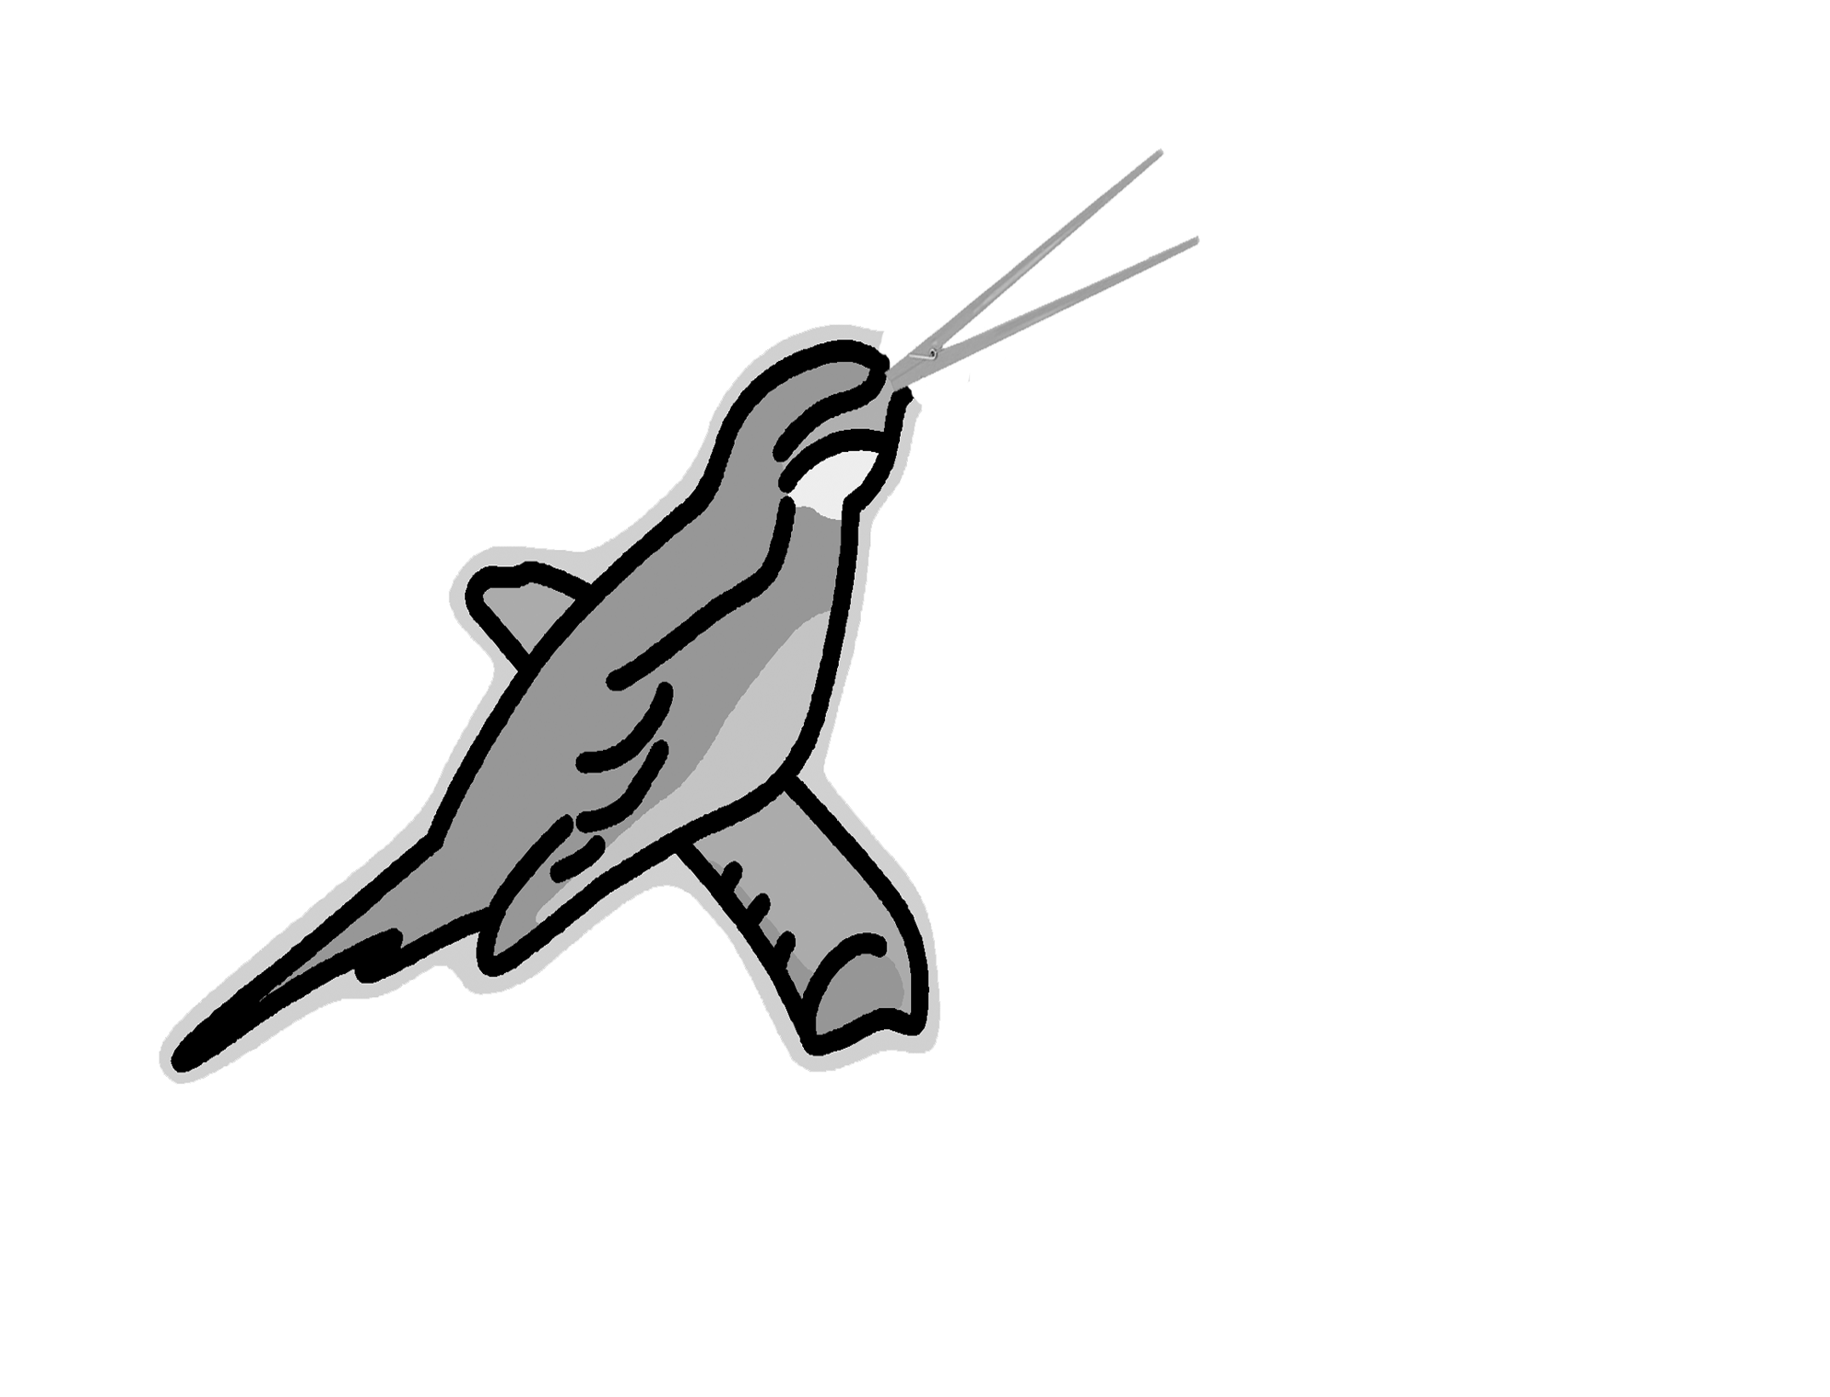
Adaptation Lab

Bird Beak Lab

Background Information
An adaptation is a trait that helps an organism survive and reproduce. Beak shape and size is an example of an adaptation. In this lab, you will see how certain adaptations can increase the bird’s chances of acquiring food. You will use utensils such as clamps, forceps, chopsticks, and spoons to represent a type of bird beak. You will then use utensils to pick up food as represented by toothpicks (worms), pennies (bugs), marbles (fruit), and beans (seeds). The cups represent the bird’s stomach.

Problem
Which beak type is best adapted or suited to obtain certain foods?

Hypothesis Which bird beak is best suited for eating worms?______________
Which bird beak is best suited for eating bugs? ______________

Which bird beak is best suited for eating fruit? ______________
Which bird beak is best suited for eating seeds? _____________

Materials
Clamps  Forceps  Chopsticks  Spoons  Toothpicks  Pennies | Beans  Marbles  Cups  Calculator  Time keeper

Procedure
- Choose a beak type from the tray given in your group. Use the cup to represent the bird’s stomach. Use the utensils appropriately.
- When the signal is given, you will have 15 seconds to try to put as much food as possible into the bird’s stomach. PUT ONLY ONE FOOD ITEM AT A TIME. DO NOT USE YOUR HANDS TO TOUCH THE FOOD!
- Count and record the amount of food on Data Table I for the beak type.
- Calculate group averages.

Conclusion
- How did variations in bird beak types affect survival of the birds?_____________________ ______________________________________________________________________________________________________________________________________________
- How is this lab an example of evolution by natural selection?__________________________ ______________________________________________________________________________________________________________________________________________
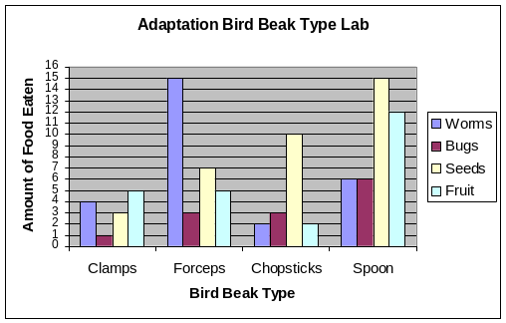
- Graph your results. You are graphing the Bird Beak type and the amount of food eaten. See sample graph.

Data
DATA TABLE I: Individual Data and Group Averages
Beak Types | # of Worms  (toothpicks) | Group Average | # of Bugs  (pennies) | Group Average | # of seeds  (beans) | Group Average | # of fruit  (marbles) | Group Average
Clamps

Forceps

Chopsticks

Spoon

Food Name | Represented by | Calories
Worms | Toothpicks | 10
Bugs | Pennies | 15
Seeds | Beans | 10
Fruit | Marbles | 15

Beak Type | To Survive | To Reproduce
Large Beak (clamps, spoon) | 60 | 110
Medium Beak (forceps) | 45 | 90
Small Beak (chopsticks) | 25 | 50

Analysis: Use your group averages to fill in the Analysis table.
Beak Type | Food best adapted to eat | Calories eaten with best food source | Did it survive with best food source? | Did it reproduce with best food source?
Clamps
Forceps
Chopsticks
Spoon

